A Major Project Synopsis on

DIGITAL TRANSACTION

Submitted to Manipal University, Jaipur

Towards the partial fulfillment for the Award of the Degree of

**MASTER OF COMPUTER APPLICATIONS**

2023-2025

by

KULDEEP SINGH

23FS20MCA00076



Under the guidance of

Ms. Monika Vishwakarma

**Department of Computer Applications**

**School of AIML, IoT&IS, CCE, DS and Computer Applications**

**Faculty of Science, Technology and Architecture**

**Manipal University Jaipur**

**Jaipur, Rajasthan**

**2025**

**Introduction:**

Paybuddy is an **online digital transaction website** designed to connect people and make effortless payments and link bank accounts seamless payments. Unlike traditional networking transaction processes that emphasize handling money through physical means, helping students, professionals, business, and other people from different sectors to make transactions handy and effortless.

Quick processing of payments and fund transfers. Real-time tracking of the status of a transaction, including pending, completed, or canceled states. Users can load funds, view balance, and make transactions directly through their digital wallet.

By integrating **modern web technologies** such as **React.js, Node.js, Express.js, and MongoDB**, paybuddy offers an intuitive, user-friendly interface with features like **user registration, security, secure payment gateway, integration with digital wallets and much more.**

**Why Choose paybuddy?**

1. For business and Professionals:

* Convenience and accessibility.
* Increased security and global reach.
* Expand your reach and be cost effective etc.

1. **For banks:**

* Increased transparency.
* Cost effective and enhanced customer support.
* Improved record keeping and automation and efficiency.

1. **Motivation**

* Many people struggle for cash problems, digital transaction solves that problem effectively.
* Helps keeping the record for business and individuals
* This platform will help people around the globe to transfer money effectively and efficiently seamless increased security and much more

1. **Problem Statement:**

To develop a digital transaction website that provides a secure, user-friendly, and scalable platform that allows businesses and consumers to perform transactions efficiently while ensuring data privacy and regulatory compliance and seamless. The website will aim to solve these problems which are listed below.

* **Security Concerns**: Users worry about the safety of their financial information during online transactions. Cybersecurity threats such as fraud, hacking, and data breaches are persistent issues.
* **User Experience**: Current digital transaction platforms often have complex and non-intuitive user interfaces, leading to difficulty in navigation and longer processing times.
* **Lack of Integration**: Users need a platform that integrates multiple payment methods (e.g., credit cards, bank transfers, digital wallets) in one unified interface. Many existing solutions fail to provide seamless integration across platforms.
* **Cross-Border Transactions**: International users face challenges with currency conversions, high transaction fees, and delayed processing times in cross-border payments.
* **Customer Support**: Lack of efficient customer service for resolving issues related to transactions, leading to user frustration
* **Regulatory Compliance**: Businesses need a solution that complies with local and international regulations regarding financial transactions, including anti-fraud and anti-money laundering laws.

1. **Methodology/ Planning of work:**

**⁠ Creating the UI using React.js. The frontend will include different components:**

* **Home Page** – Overview and login/signup
* **Dashboard** – User profile and skill management.
* **Login and sign in component. -** Login or signup options for users.
* **Check balance and make digital transaction** – Connect and communicate with matched users, and to other users with upi linked bank accounts.
* **Projects & Opportunities** – Users can collaborate on projects or find learning groups.

1. **Backend Development using Node.js & Express.js:**

* **Authentication:** OAuth and email-based login.
* **Fetch and axios api for integration:** Offer APIs for businesses to integrate your transaction
* **Messaging System:** Real-time chat for seamless communication.
* **Data Management:** Stores user profiles, skills, and activity logs.

1. ⁠**Database Implementation using MongoDB:**

* **User Profiles** – Stores most profiles and makes it easier to make transactions.
* **Matches & Connections** – Saves previous transaction and balance history.

1. **Development Flow:**

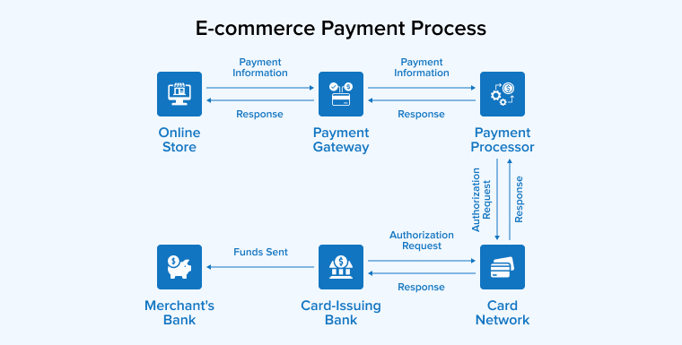

1. **Requirements for proposed work:**
2. **Software Requirement:**

* Operating System: Windows, Linux, MacOS
* User Interface: ReactJS
* Database: MongoDB
* Backend: NodeJS with ExpressJS
* Front-end: reactJs, tailwind, zod, validation

1. **Hardware Requirement:**

* Hardware: Intel i3 or better
* RAM: 4GB (minimum)
* Hard Disk: 20 GB Hard Disk Space

1. **Bibliography/References**

* O'Connor, J. T. (2019)**.** *Digital Payments: The Future of Transactions*. New York: Springer.
* This book covers the evolution of digital payment systems, their security, and future trends in digital transactions.
* Payment Systems Report**. (2023).** "The Growth of Digital Payments in Emerging Markets." Retrieved from <https://www.paymentsystemsreport.com>.
* This source provides insights into how digital payment methods are being adopted in emerging markets.
* National Cybersecurity Institute**. (2022).** "Securing Digital Transactions: Best Practices." Retrieved from <https://www.nationalcybersecurityinstitute.org>

.

* A useful online resource offering best practices and security tips for securing digital transactions.
* R. Raj, "Building AI-Driven Web Applications," Springer, 2021.
* E. Brown, Learning JavaScript Design Patterns, O'Reilly Media, 2018.
* M. Haverbeke, Eloquent JavaScript: A Modern Introduction to Programming, No Starch Press, 2020.
* K. S. Raghunandan, "Real-time Collaboration and AI-based Matchmaking," IEEE Transactions on Web Intelligence, vol. 14, no. 2, pp. 145-157, 2022.
* D. Crockford, JavaScript: The Good Parts, O'Reilly Media, 2008.
* B. Stroustrup, Programming: Principles and Practice Using C++, Addison-Wesley, 2014.
* D. K. Chappelle, "MongoDB in Large-Scale Applications," ACM Computing Surveys, vol. 53, no. 3, pp. 22-34, 2020.